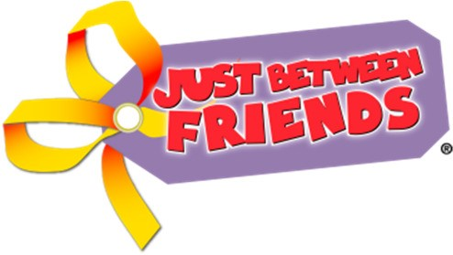
Just Between Friends of Waukesha
Clothing items accepted at the Spring/Summer Sales Event
Lightweight and Summer Material Only
Please always Bring the Best of your Best and Price your items to SELL!

- Cap/Short Sleeve Shirts
- Long sleeve Shirts
- Tank Tops
- Dresses (Short, long sleeve or tank)
- Skorts
- Skirts
- Shorts
- Capri’s
- Jeans
- Overalls (not lined)
- Lightweight Pajama’s (no fleece)
- Swimsuits
- Beach Cover-Ups
- Jackets
- Zip Up Hoodies
- Sweaters (cardigans)
- Shoes: All season shoes except no snow boots
- Junior Clothes – Limit of 10 items (Sizes XS – Medium sell best)
- Maternity Clothes: Limit of 20 items

Drawstring Policy: Due to Safety Standards regarding drawstrings we will be unable to accept a drawstring in clothing items sizes 0-16. This police include drawstrings in hoods, around the waist of upper garments and at waistbands. We will be able to accept items that have “fake” drawstrings commonly found on pants that are attached to garments.

