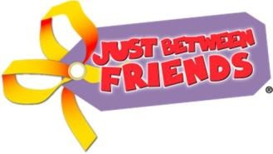
Just Between Friends of Waukesha
FALL / WINTER SALE
Please always Bring the Best of your Best and price your items to SELL!

Clothing accepted (Size NB – 18)
- Cap/Short Sleeve Shirts (no tank tops)
- Long Sleeve Shirt and Sweatshirts (no drawstrings)
- Snow Suits & Snow Pants
- Pants
- Jeans
- Overalls
- Skirts (winter weight/styles)
- Jumpers (winter weight/styles)
- Holiday Dresses (long and short sleeve)
- PJ’s (short & long sleeve – no tank styles)
- Sweaters (long and short sleeve)
- Fleece Vest or Jackets
- Coats
- Winter Outwear
- Swimsuits
- Junior Clothing (20 item limit for elem/middle/high school ages)
- Maternity Clothing (20 item limit)

Shoes accepted (Size 0 infant – 7 junior)
- Tennis shoes
- Dress shoes/boots
- Slippers
- Robeez (and other similar brands)
- Rain boots
- Winter boots

Drawstring Policy: Due to Safety Standards regarding drawstrings we will be unable to accept a drawstring in clothing items sizes 0-16. This policy includes drawstrings in hoods, around the waist of upper garments and at waistbands. We will be able to accept items that have “fake” drawstrings commonly found on pants that are attached to garments.

