*JBF Proprietary Information*

**TOYS**

**BEDDING**

**Toys**- battery operated, electronic games (E or T), DVDs (G, PG or PG13), gaming systems, iPods, MP3 players, DS, DSI, Xbox, Wii, Nintendos, computer games, puzzles, riding toys, age appropriate books, music CDs, electronic stuffed animals, character stuffed animals, new with tags stuffed animals, kitchens, girl toys, boy toys, Build a Bear,

**Toys**- toys without batteries, items with missing pieces (unless noted on tag), items that have been recalled and not fixed (if fixed, must be noted on tag), stuffed animals, VHS tapes, TVs, VCRs, DVD players, appliances, (M) mature electronic games, (R) rated DVDs, scratched DVDs, cassette tapes, Gameboys, vintage toys, RECALLED ITEMS

**Bedding**- bumper pads, no adult bedding, no king or queen sized bedding, stained or cracked crib mattresses, twin size mattresses (sold without bed), RECALLED ITEMS

**Bedding**- **MUST BE PRICED UNDER $50**  
crib bedding (without bumper pad), receiving blankets, sheets and shams for kids, sleeping bags for kids, crib mattresses in EXCELLENT condition

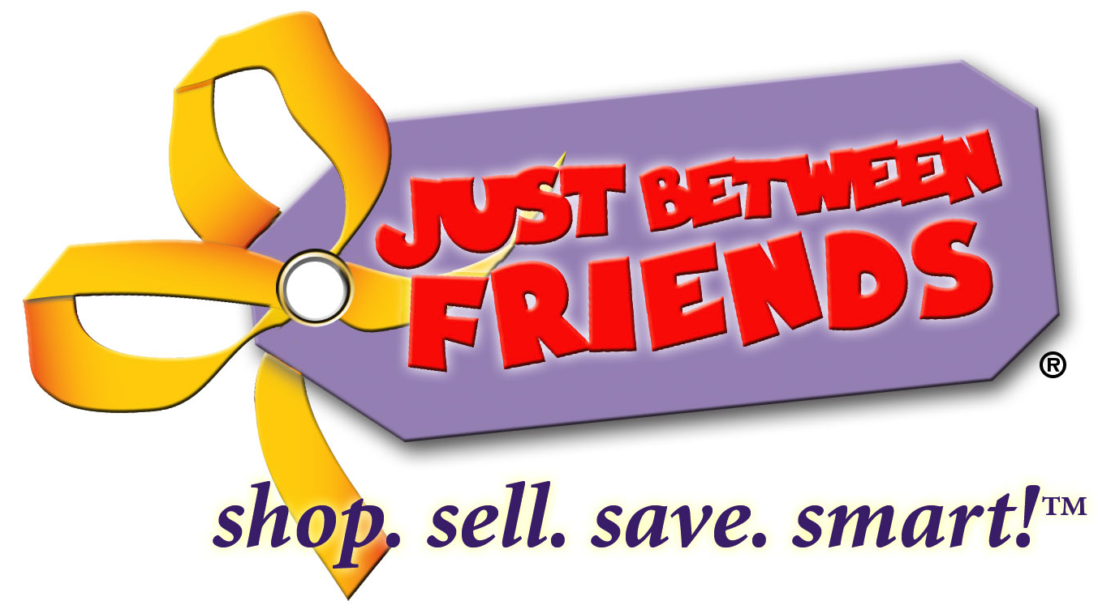

**SPRING/SUMMER – WHAT WE ACCEPT**

**CLOTHING: Tops**- winter themed or holiday shirts, Halloween costumes, Valentine’s Day, heavy long sleeve shirts, velvet, winter sweaters, heavy winter coats, ski wear, fleece tops, turtlenecks, thermal shirts, RECALLED ITEMS

**CLOTHING:** Warm Weather Clothing – Think warmer weather! **Tops**- short sleeve shirts, lightweight long sleeve shirts, tank tops, spring sweaters (to go over outfit), lightweight summer & sundresses, onesies (short sleeve and long sleeve), swimsuits lightweight coats, raincoats, lightweight hoodies, windbreaker jackets, Easter outfits, dancewear, 4th of July themed tops

**What is NOT OK to Sell**

**What is OK to Sell**

**OUTDOOR**

**CLOTHING**

**Sports & Outdoor Play**- dirty or rusted bikes, cracked or rusted sandboxes, items not too weathered, helmets over 5 years, RECALLED ITEMS

**Sports & Outdoor Play**- sporting equipment, cleats, skates, dance leotards, dance shoes, bikes, bike trailers, bike helmets, outdoor toys, swings sandboxes, water tables, play houses, slides

**Winter**- sleds, snow toys and snow accessories

**Swim**- pool toys, life jackets, outdoor fun toys

**Accessories**- summer hats, tights, belts, socks, clean underwear, onesies, hair bows, ties, sunglasses

**Accessories**- gloves & winter hats, RECALLED ITEMS

**Shoes**- slippers, sandals, dress shoes water shoes, tennis shoes, flip-flops, rain boots

**Shoes**- boots, winter type shoes, fleece lined Crocs, dirty shoes, shoes with too much wear & tear, RECALLED ITEMS

**Juniors**- no adult clothes (adult brands), may not bring over 5 items, RECALLED ITEMS

**Juniors**- sizes 0, 1, 3, 5, 7, 9, 11, 13, 15 (must be current fashion, JBF may pull items if not current)

**Maternity**- may not bring over 5 items, RECALLED ITEMS

**Maternity**- 5 best any season maternity outfits (must be in current fashion)

**Bottoms**- heavy pants (like corduroy & wool), lined pants, fleece pants, fleece pajamas, RECALLED ITEMS

**Bottoms**- shorts, skirts, Capri pants, jeans, lightweight pants, dress pants, light weight pajamas (can be long sleeve)

**DECOR**

**CRAFTS**

**Baby Equipment & Accessories (Mommy Mart)**- Breast pumps and breast pump accessories RECALLED ITEMS

**Baby Equipment & Accessories (Mommy Mart)**- Pack N Plays, car seats (less than 5yrs old), booster seats (less than 5 yrs old), strollers, infant car seat/stroller travel systems (less than 5 yrs old), high chairs (must have straps), bouncy seats, Jumperoos, swings, pacifiers, potty chairs, Bumbos with strap, diapers, diaper pails, feeding items, sippy cups, Boppies, body pillows, bibs, car seat covers, diaper bags, back packs, safety items, shopping cart covers, kid towels

**Nursery & Kid Décor**- holiday décor, regifting items, picture (not kid specific), regular lamps, regular rugs, household décor items, RECALLED ITEMS

**Nursery & Kid Décor**- kid lamps, kid room décor, kid rugs, kid pictures, kid shelves, party favors,

**Crafts**- NO ADULT CRAFTS, RECALLED ITEMS

**Crafts**- Kid crafts are accepted

**What is NOT OK to Sell**

**What is OK to Sell**

**BABY ITEMS**

**FURNITURE**

**Furniture**- bassinets, kid’s bedroom furniture, toddler beds, twin beds, bunk beds, rocking chairs, desks, cribs, kid dressers, changing tables, cradles, co-sleepers, book shelves

**Furniture**- cribs manufactured before July 26, 2011, drop side cribs, any recalled item that has not been repaired, drawn on furniture, Nap Nanny’s , couches, love seats, RECALLED ITEMS

This is just a sample of what is OK to sell at the SPRING/SUMMER sales based on frequently asked questions. If you have specific questions please email Jill and Jessica at arvada@jbfsale.com.

Please NOTE – All consignors are required to check their personal items with the [**CPSC. gov**](http://www.cpsc.gov/) website for recalls. If a recalled item is pulled off the floor, the consignor will be contacted and fined $20.

**Items that are stained, torn, dirty, broken, or missing parts will be pulled from the sales floor and $.50 per item will be deducted from your consignor check after the 3rd item is pulled.**

*JBF Proprietary Information*